**The Reformed Church of Steen**

Sunday, August 10, 2025



Phone: 507-855-2336

E-mail: [steenreformed@alliancecom.net](mailto:steenreformed@alliancecom.net)

Website: [www.steenchurch.org](http://www.steenchurch.org)



**The Consistory**

Elders: Deacons: Norm Sjaarda-Vice President Dylan Bosch

Kraig Scholten Chad Rauk

Brad Bosch Chris Harnack-Chairman

Larry Bosch Tyler DenHerder

Dave Esselink Justin Maciejack

Dale Sandbulte-Clerk Kyle VanRuler

Jeremy Wiersema, Senior Pastor (712)324-1345

Julianna Kempema, Associate Pastor (616)337-4696

**Morning Service at 9:30 a.m.**

Prelude

*Welcome/Call to Worship ~ 2 Timothy 1:7

*Mutual Greetings

*Opening Songs ~ Hymn#350 “Tis So Sweet to Trust in Jesus”

Congregational Prayer

Special Offering for the Banquet

Offertory Song ~ Hymn #279 “Faith of Our Fathers”

Scripture ~ Numbers 13:26-33 pg 228

2 Timothy 1:3-7 pg 1852

Message ~ “Fear Factor”

Announcements

Offertory Prayer/Offering

Offertory Song ~ Hymn #409

“I Know Whom I Have Believed”

*Benediction

*Closing Song ~ “Make Me A Servant”

*Please stand if you are able

We want to thank Irwin VanLeeuwen for leading the service this morning.

This morning’s coffee time is being hosted by Dale & Sue Bartels in honor of their 60th wedding anniversary, which was on August 6th.

**Bible Verse of the Month:**

**For God did not give us a spirit of timidity,**

**but a spirit of power, of love and of self-discipline.**

**2 Timothy 1:7**

**The Lord’s Prayer**

Our Father, who art in heaven, hallowed be Thy Name.

Thy kingdom come, Thy will be done on earth,

as it is in heaven. Give us this day our daily bread,

And forgive us our debts, as we forgive our debtors.

Lead us not into temptation, but deliver us from evil;

For Thine is the kingdom, and the power, and the glory,

forever. Amen.

**The Apostles’ Creed**

I believe in God, the Father Almighty,

maker of heaven and earth,

I believe in Jesus Christ His only son, our Lord;

He was conceived by the Holy Spirit, born of the Virgin Mary,

suffered under Pontius Pilate, was crucified, dead, and buried.

He descended into hell.

The third day He rose again from the dead.

He ascended into heaven, and is seated at the right hand of God the Father Almighty.

He will come again to judge the living and the dead.

I believe in the Holy Spirit, the holy Christian Church,

the communion of the saints, the forgiveness of sins,

the resurrection of the body, and the life everlasting. Amen

***Activities for the Week***

***Monday:*** Mendistry at 5:45 a.m.

***Wednesday:***  Serve at the Banquet

***Announcements & Events***

**No WOW** on Wednesday.

**August Mission of the Month**: Steen Reformed Church will be serving at **the Banquet** on Wednesday.  We still need volunteers to prep the meal from 2:00-5:00 p.m and to help serve the meal from 5:00-8:00 p.m.

**The Church Carnival** will be held Wednesday, August 20th from 5:30-8:00 p.m. This year we will be having the carnival in the city park. There is a sign-up on the welcome desk for food donations and volunteers. There will also be a Cruise’n for Christ car show on Main Street. All cars, trucks, tractors or motorcycles are welcome.

**Directory Update:** Please check the table in fellowship hall to make sure your address, phone number, email address are correct; or add your information to it.

We are in need of **two RCYF sponsors**. If you are interested, talk to an Elder.

**The Sunday School Dept.** is looking for a Primary Dept. assistant director and 4 teachers. If you would be willing to fill any of these roles for our kids, please see Dale Sandbulte.

**Simba Ministries Mission Trip November 22-December 3.** Chase Ward is organizing another mission trip to Kenya this year. If anyone is interested in going, please contact Dave Tilstra by August 15th so airplane tickets can be bought. Eric Vahl has gone on this trip in the past so if you have any questions, he would be a great resource.

**"Everyday-Ambassador Practicum"** will be from 9AM--2PM on Sat., August 16, at the Empower Campus, 1915 E 8th St, Sioux Falls. Come for good snacks & beverages, interactive Bible study, getting "tooled-up," then going out in an engaging environment as Jesus' ambassadors. It's FREE. This training will equip you to more readily rise up as God's representative wherever you are, and as one about whom He proclaims: "beautiful are the feet of those who bring Good News." Questions or to register, text or call Fred of New Roots Ministry, at 605-376-6330, OR Aaron Myers of Crescent Project, at 605-659-5961.

**A Note From the Librarian:** The featured book is

"Come Thirsty" by Max Lucado. There are lots of new books to check out and still some free books on the cart.

Men and women, you are invited to the **BEYOND** **YESTERDAY** conference, hosted by Bible League Volunteers on September 8 and 9.  You will be inspired by the speaker, Jason VanRuler, and by updates from Bible League regarding the wonderful effect of the Bible on those who receive a copy.  A dinner is scheduled for Monday, the 8th, cost is $25.  Tuesday, the 9th, is a full day with registration costing $40, or $30 without the lunch. Register now at bibleleague.org/tickets. Registering after August 17 will add a late fee of $5 to the cost, and registration closes August 31.  If you have questions, please call Lorraine at 855-2281.

**Common Grounds Coffee** is in need of 2 or 3 more people who would be willing to set up and clean up the coffee bar on Sunday mornings. If this is a ministry you have been enjoying on Sunday mornings, we could really use your help for it to continue to not be a burden on just a few people. Our goal is that you would only have to do it one or two months a year. If you are interested, please contact

Vonnie Baker (507-227-0022) for more details.

The Fellowship Committee is inviting everyone to go trap shooting September 20th. More details coming soon.

A Grief Share support group for people grieving the death of a loved one is starting Monday, September 8, 6:30-8 PM at Generations, 105 S. Estey St, Luverne. Topics will include how to manage grief-related emotions such as loneliness, anxiety, sadness, anger, and regret; how to cope with the changes in your life and relationships; how to recognize what’s normal in grief; and what to do if you feel stuck or hopeless. Come for all 13 weekly meetings, or whenever you can make it. Marlen & Jeanne Van Otterloo will facilitate. More information at griefshare.org or call American Reformed Church

at 507-283-8600.

Lyon County Food Shelf is no longer taking food donations.

***Opportunities to Serve the Body of Christ***

**This Week Next Week**

|  |  |  |
| --- | --- | --- |
| Organist | Glenda Sandstede | Praise Team |
| Ushers | Tom VanDerWeerd  Alan Baker  Al Hoogers | Tom VanDerWeerd  Alan Baker  Al Hoogers |
| Nursery | Amanda Rozeboom  Kelsey Baker  Huck Terry | Stephanie Roozenboom  Hadley Roozenboom  Malachi Bush |
| Greeters | Harvey & Heidi Gehrke  Bernie Hanson | Chris & Jodi Harnack  Jake & Kathy Hoogendoorn |
| Children’s  Message | Tyler Bush | Clint Roozenboom |
| Camera | Logan Bosch | Micah Bush |
| PowerPoint | Vonnie Baker | Cooper Gehrke |
| Sound | Missy Bosch | Chris Harnack |
| Coffee Time | Dale & Sue Bartels |  |
| Ministry of  Music | Dale & Sue Bartels | Randy & Janie Baker |



August 10 – Tessa VanWyhe

12 – Bryce Metzger

Tami Rauk

13 – Justin Esselink

Thank you for letting me be able to go to camp. I had fun learning more about God and making new friends.

Kelsey Baker



We are getting ready for our new Wednesday night program but we can’t make it a success without your help. We are planning on a start date of September 10th and the final night being April 22nd. Classes will meet from 6:30-8:00. We are also looking for 2-3 people to help out in the nursery, 1 person to lead the song time and 1-2 people to lead games.

Also below are listed the director and leader roles that need to be filled. Please see Krista Bosch with any questions or the role that you would like to help in.

**Summary of Awana Roles**

Cubbies (3- and 4-year-olds)

Sparks (K – 2nd grade)

**Director Roles (1 director for Cubbies and 1 director for Sparks)**

* Plan individual schedule for the night within particular area
* Prepares classroom space with whatever material may be needed for the night (i.e. crafts, paper, pencils, etc.)
* Greet parents and children as they arrive and at pick up
* Clean up room afterwards

**Leader Roles (3 leaders for Cubbies and 4 leaders for Sparks)**

* Be 10/15 minutes early to Club
* Greet and engage with children
* Be prepared to share the Gospel
* Implement the night’s lesson, hear verses and sign off verses

With the upcoming midweek year we will be participating in **Gems and Cadets with the Luverne CRC.**  This will be for 3rd through 8th graders. If you are interested in being a part of this amazing opportunity for our youth, please reach out to Tyler DenHerder for more information.



* Those that are homebound and in nursing homes:

Anna Mae Berghorst, John Bosch, Rich VanDerBrink and Lucy VanWyhe.

* Those in our church and community who are dealing with cancer: Marv Albers, Doug Boeve, Holly Horstman, Heather Johnson, Shane McMath, Seth Rozeboom, Robert Sandbulte, Merle Sandstede, Starla Scholten, Rick Tatge, John Tilstra, Deb VanWyhe, Sheila Vis and Ivan Wiersema.
* Herm Besselsen, Bernice Tilstra’s sister, as she struggles with health issues.
* Adam Huisman as he heals from his hip infection and surgery.
* Sophie Gehrke as she heals from her heart procedure.
* Dillan Kroon’s son, Silas, who suffered a stroke, is on life support and put on a transplant list.
* Tyler Bush as he heals from his surgery on a torn Achilles tendon.
* The vacant churches of the Alliance of Reformed Church.

If you need to contact the church secretary, Tammy Bos, you can do so by email, [steenreformed@alliancecom.net](mailto:steenreformed@alliancecom.net), by calling the church during her posted office hours, or by calling/texting her at 605-951-8254. Thank you!

This week’s office hours ~ Monday 5:30 a.m.-8:30 a.m.

Tuesday 9:00-12:00

Wednesday 9:00-11:00

Friday 9:00-12:00

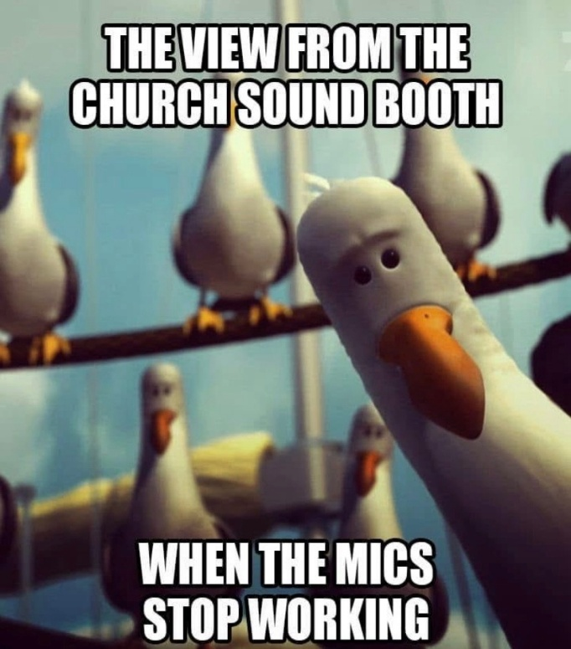

General Fund: Dylan Bosch

Building Fund: Tyler DenHerder

Benevolent Fund: Chad Rauk

Sunday School Superintendent: Dale Sandbulte

Midweek Superintendent: Rex Metzger

Organists/Pianists: Lisa Kiers, Kendra Paulsen, Lorraine

Sandbulte, Glenda Sandstede, Debbie Tilstra

Midweek Meal Supervisor: Dolly Van Der Weerd

RCYF Sponsors: Tyler & Kala Bush, Greg & Laura Leenderts,

Eric & Kilee Uittenbogaard

Missions Committee: Chairman-Dave Tilstra,

Treasurer-Nicie Bosch

Sidney Bonilla, Tyler Bush, Annette Elbers, Jodi Harnack,

Eric Kiers, Sadie Knobloch, Kendra Paulsen,

Eric Uittenbogaard, Dolly Van Der Weerd

Steen Women’s Ministry: President-Amanda Wiersema

Vice President-Janice Klosterbuer

Treasurer-Marilyn Jellema

Fellowship Committee: Annie Bos, Larry Bosch, Troy Bosch,

Stephanie Roozenboom, Dale Sandbulte

Church Decorating Committee: Vonda Klarenbeek,

Holly Mulder, Glenda Sandstede, Donna Sjaarda

Library Supervisor: Kendra Paulsen

**In case of any cancellations, you will receive a phone call from the church.