The Reformed Church of Steen
Sunday, May 10, 2026



Phone: 507-855-2336
E-mail: steenreformed@alliancecom.net
Website: www.steenchurch.org

The Consistory
Elders: Deacons:
Brad Bosch-Vice President Chris Harnack-Chairman
Larry Bosch Tyler DenHerder
Dave Esselink Justin Maciejack
Dale Sandbulte Kyle VanRuler
Dennis Mulder Dustin Bonnema
Stan VanWyhe Chase Bosch

Jeremy Wiersema, Senior Pastor (712)324-1345
Julianna Kempema, Associate Pastor (616)337-4696

Morning Service at 9:30 a.m.

Prelude
*Welcome/Call to Worship ~ Matthew 10:32
*Mutual Greetings
*Opening Songs ~ Hymn #60 “Morning Has Broken
Hymn #536 “Happy the Home When God Is There”
Congregational Prayer
Baptism of EllaRae Jo Fest
Children’s Message ~ Angie Sjaarda
Ministry of Music
Scripture ~ Genesis 2:4-15 pg 3
Message ~ “Work”
Profession of Faith ~ Micah Bush
Announcements
Offertory Prayer/Offering
Offertory Song ~ Hymn #524 “It Took A Miracle”
*Benediction
*Closing Song ~ “Make Me A Servant”

*Please stand if you are able

Bible Verse of the Month:

“Whoever acknowledges me before men,
I will also acknowledge him before my Father in heaven.
Matthew 10:32

Evening Service at 6:00 p.m.

Prelude
*Invocation
Opening Songs ~ Hymn #18 “Come, We That Love the Lord”
verses 1,2,3,5
Hymn #325
“Here, O My Lord, I See Thee Face to Face”
Pastoral Prayer
Scripture ~ Psalm 119:113-120 pg 962
Message ~ “Sustained”
Prayer of Blessing
Hymn #326 “Softly and Tenderly” vs 1-3
*Benediction
Closing Song ~ Hymn #326 “Softly and Tenderly” vs 4

*please stand if you are able

The Lord’s Prayer
Our Father, who art in heaven, hallowed be Thy Name.
Thy kingdom come, Thy will be done on earth,
as it is in heaven. Give us this day our daily bread,
And forgive us our debts, as we forgive our debtors.
Lead us not into temptation, but deliver us from evil;
For Thine is the kingdom, and the power, and the glory,
forever. Amen.

The Apostles’ Creed
I believe in God, the Father Almighty,
maker of heaven and earth,
I believe in Jesus Christ His only son, our Lord;
He was conceived by the Holy Spirit, born of the Virgin Mary,
suffered under Pontius Pilate, was crucified, dead, and buried.
He descended into hell.
The third day He rose again from the dead.
He ascended into heaven, and is seated at the right hand of God the Father Almighty.
He will come again to judge the living and the dead.
I believe in the Holy Spirit, the holy Christian Church,
the communion of the saints, the forgiveness of sins,
the resurrection of the body, and the life everlasting. Amen

Opportunities to Serve the Body of Christ

This Week Next Week
Organist | Glenda Sandstede | Debbie Tilstra
Ushers | Joshua Wiersema  Chad Rauk  Norm Sjaarda | Joshua Wiersema  Chad Rauk  Norm Sjaarda
Nursery | Amanda Rozeboom  Hadley Roozenboom  Huck Terry | Stephanie Roozenboom  Londyn DeBoer  Teagan VanWyhe
Greeters | Brad & Linda Bosch  Brandon & Jill Bosch | Chase & Jacey Bosch  Dylan & Krista Bosch
Children’s  Message | Angie Sjaarda | Kilee Uittenbogaard
Camera | Logan Bosch | Micah Bush
PowerPoint | Dustin Bonnema | Cooper Gehrke
Sound | Missy Bosch | Chris Harnack
Coffee Time | Tim & Trista Bosch & family | Gertrude Rozeboom
Ministry of  Music | Justin & Kelsey Esselink | Eli & Kenadie Fest

Activities for the Week

Monday: ~ Mendistry at 5:45 a.m.

Thursday: ~ Mendistry at 7:00 p.m.

Advanced Dates:

Last day of Sunday School is May 17th

Race Night at Rapid Speedway – July 24th

Sunday School Carnival – August 19th

Sermon Notes

Work is a part of the original design

Work, God declared in creation, to be very good

Work is something we have been created to delight in

God works

John 5:17 “My Father is always at his work to this very day, and I, too, am working.”

As his image bearers, we should also work.

Our work in this world must be focused on God’s will.

Psalm 90:17 “May the favor of the Lord our God rest on us; establish the work of our hands for us—yes, establish the work of our hands.”

Why you do what you do?

Colossians 3:23 “Whatever you do, work at it with all your heart, as working for the Lord, not for men.”

Announcements
No Sunday School today.
Vacation Bible School—June 1-5 from 2:00-5:00.
It’s time to sign up the kiddos (pre-school thru 6th grade); and there are a variety of areas to help out also. Both sign up sheets are on the welcome desk.
Let’s make it a fun week for all!
Mission of the Month: Tuff Home Country Store. Some ideas to shop for the Country Store, personal items, shampoo, deodorant, lotions, toothpaste, toothbrush, large word search/puzzle books, all occasional greeting cards, color books, crayons/colored pencils, nail polish, nail policy remover, slippers, mini cans of pop, small treats – candy bars, chips, cookies. Please set your donations on the pew in fellowship hall.
Inspiration Hills Camp registration: The church will pay 100 percent for a church student and one friend. Let the deacons know if you are interested. Brochures are available in the fellowship hall.

A Note from the Librarian – The featured book is called “The Power of a Praying Parent”. Come check out the great selection of books we have on hand.

Directory Update:
Gawaine Diekevers new cell # 507-290-3824



- Those that are homebound and in nursing homes:
Joann Paulsen, Rich VanDerBrink and Lucy VanWyhe.

- Those in our church and community who are dealing with cancer: Marv Albers, Rodney Bajema, Carole Bosch, Brian Bruxvoort, Doug Chapman, Holly Horstman, Heather Johnson, Shane McMath, Robert Sandbulte, Merle Sandstede, Rick Tatge, Bernice Tilstra,
Deb VanWyhe and Sheila Vis.

- Mark DeBoer as he heals from double bypass surgery.

- Sympathy of Rex and Erin Metzger and the entire Metzger family on the death of a nephew, Caden Metzger, who passed away Thursday.

- Deb VanWyhe as she has been moved to the Dougherty Hospice House.



May 10 – Cole Baker

15 – Sawyer Bosch

If you need to contact the church secretary, Tammy Bos, you can do so by email, steenreformed@alliancecom.net, by calling the church during her posted office hours, or by calling/texting at 605-951-8254. Thank you!

This week’s office hours ~ Monday 5:30 a.m.-8:30 a.m.
Tuesday 9:00-12:00
Wednesday 9:00-11:00
Friday 9:00-12:00

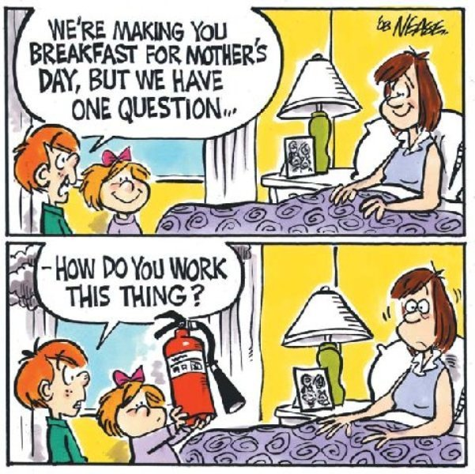

General Fund: Chris Harnack, Dustin Bonnema
Building Fund: Tyler DenHerder, Kyle VanRuler
Benevolent Fund: Justin Maciejack, Chase Bosch

Sunday School Superintendent: Dale Sandbulte
Midweek Superintendent: Rex Metzger

Awana Leader: Krista Bosch
Gems Leader: Julianna Kempema
Cadets Leaders: Tyler DenHerder & Dave Esselink

Organists/Pianists: Lisa Kiers, Kendra Paulsen, Lorraine Sandbulte, Glenda Sandstede, Debbie Tilstra

Midweek Meal Supervisor: Dolly Van Der Weerd

RCYF Sponsors: Tyler & Kala Bush, Greg & Laura Leenderts,
Devin & Alexis Klarenbeek, Eric & Kilee Uittenbogaard

Missions Committee: Chairman-Dave Tilstra,
Treasurer-Nicie Bosch
Sidney Bonilla, Tyler Bush, Annette Elbers, Jodi Harnack,
Eric Kiers, Sadie Knobloch, Kendra Paulsen,
Eric Uittenbogaard, Dolly Van Der Weerd

Steen Women’s Ministry: President-Janice Klosterbuer
Vice President-Susan Vis
Treasurer-Marilyn Jellema

Fellowship Committee: Annie Bos, Larry Bosch, Troy Bosch,
Stephanie Roozenboom, Dale Sandbulte, Howie Vis
Church Decorating Committee: Vonda Klarenbeek,
Holly Mulder, Glenda Sandstede, Donna Sjaarda
Library Supervisor: Kendra Paulsen
Mendistry Leaders: Fred Wilgenburg-morning
Roger Bosch-evening

